My Target: ____ / 45 or ______ % Complete on the day of the task

🖒 🖓 (Circle when your task is handed back)



**Name:**

**Yr 9 Humanites & Social Sciences**

***Economics and Business:******Assessment 9***

**Target: ___________ / 45 Weighting: 10%**

**Year 9 Economics & Business: Graphic Organiser Scams**

You have completed an activity recording data and comparing scams in September 2015, 2016 and 2017. Building on your research skills, you will once again refer to the Australian Competition and Consumer Commission (Scamwatch) website for current data about scamming in relation to online shopping in Australia. (<https://www.scamwatch.gov.au/about-scamwatch/scam-statistics>)

You will record the data in the table below for the years 2016 and 2017 for online shopping scams. Analyse the data in the table and create the Venn Diagram graphic organiser on the reverse of this page. **Note: Remember to include units ($).**

|  |  |  |
| --- | --- | --- |
| **TOTAL ONLINE SHOPPING**  **AL (AMOUNT LOST) AND NR (NUMBER OF REPORTS)** | | |
|  | **2016** | **2017** |
| **AL** |  |  |
| **NR** |  |  |
| **TOTAL MARKS** | **/3** | **/3** |

|  |  |  |  |  |  |  |
| --- | --- | --- | --- | --- | --- | --- |
| **DATA FOR ONLINE SHOPPING 2016 AND 2017** | | | | | | |
| **LIST THE TOP THREE AMOUNTS LOST FOR METHODS OF DELIVERY**  **AL (AMOUNT LOST) AND NR (NUMBER OF REPORTS)** | | | | | | |
| **DELIVERY METHOD** | **2016** | | | **2017** | | |
| **METHOD** | **AL** | **NR** | **METHOD** | **AL** | **NR** |
|  |  |  |  |  |  |
|  |  |  |  |  |  |
|  |  |  |  |  |  |
| **TOTAL**  **MARKS** | **/3** | **/6** | **/3** | **/3** | **/6** | **/3** |

**/30**

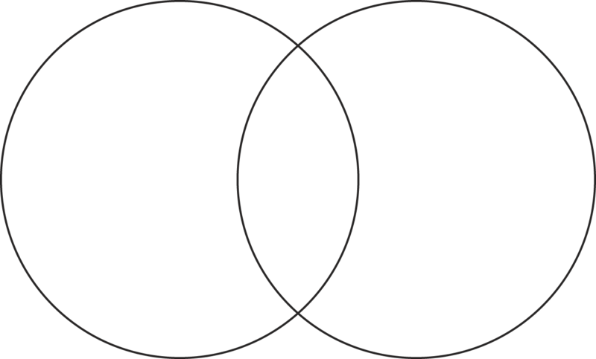

/15